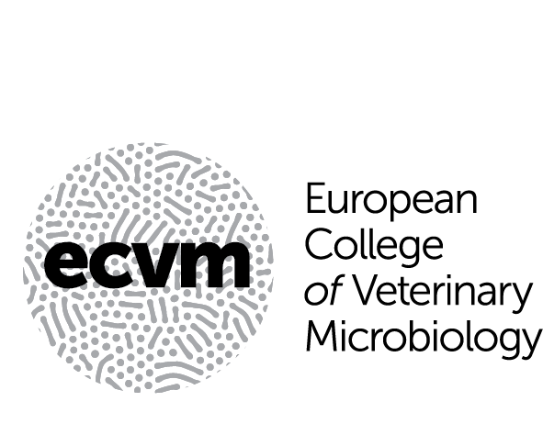

**Application to take Part 1 of the Qualifying Examination of the European College of Veterinary Microbiology (ECVM)**

The completed form must be submitted electronically by the Resident’s Supervisor to the Chairperson of the Certification and Credentials Committee and a copy sent to the Chair of the Examination Committee of the European College of Veterinary Microbiology, at least 3 months before the date of the examination.

**Name of resident**:

**Residency address**:

**Resident’s E-mail**:

I, ………………………., formally apply to take Part 1 of the Qualifying Examination of ECVM at the next offering of this examination. I confirm that I have completed two years of training (Standard Training Programme) or the equivalent (Alternate Training Programme) and have received the relevant approval from the ECVM Education Committee covering this period of training (Please attach a copy of the report from the Education Committee for the second year of your training or equivalent).

**Signature of resident**: **Date**:

**Name of Resident’s Supervisor**:

**Signature of Resident’s Supervisor**: **Date**:

**Name of Residency Director**:

**Signature of Residency Supervisor**: **Date**: